**ROBOTLINKING**

**THE LCD1602 STARTER KIT TUTORIAL**

**Preface**

### About RobotLinking

RobotLinking is a technology company focused on 3D Printer, Raspberry Pi and Arduino open source community development. Committed to the promotion of open source culture, we strive to bring the fun of electronics making to people all around the world and enable everyone to be a maker. Our products include learning kits, development boards, robots, sensor modules, development tools and printer machine. In addition to high quality products, RobotLinking also offers video tutorials to help your own project. If you have interest in open source or making something cool, welcome to join us! Visit [www.RobotLinking.com](http://www.sunfounder.com/) for more!

### About LCD1602 Starter Kit

This LCD1602 starter kit is suitable for RobotLinking Uno, RobotLinking Mega 2560, RobotLinking Duemilanove and RobotLinking Nano. All the code in this user guide is also compatible with these boards.

Our RobotLinking board is fully compatible with Arduino.

This kit walks you through the basics of using the RobotLinking board in a hands-on way. You'll learn through building several creative projects. The kit includes a selection of the most common and useful electronic components. Starting from the basics of electronics, to more complex projects, the kit will help you control the physical world with components.

In this book, we will show you circuits with both realistic illustrations and schematic diagrams. You can go to our official website [www.RobotLinking.com](http://www.sunfounder.com/) to download related code.

If you have any questions, please send an email to [support@RobotLinking.com](mailto:support@sunfounder.com). You can also leave a message and share your projects on our forum.

**Contents**

Preface 1

Components List 3

Lesson 1 Button 8

Lesson 2 Flowing LED Lights 12

Lesson 3 Buzzer 15

Lesson 4 Photoresistor 18

Lesson 5 RGB LED 21

Lesson 6 Relay 24

Lesson 7 Tilt-Switch 27

Lesson 8 Servo 29

Lesson 9 LCD1602 31

Lesson 10 Thermistor 34

Lesson 11 Voltmeter 37

Lesson 12 Automatically Tracking Light Source 39

# Components List

|  |  |  |  |
| --- | --- | --- | --- |
| No | Product Name | Quantity | Picture |
| 1 | LCD1602 Module | 1 |  |
| 2 | USB Cable | 1 |  |
| 3 | Breadboard | 1 |  |
| 4 | Jumper Wire | 65 |  |

|  |  |  |  |
| --- | --- | --- | --- |
| 5 | Resistor (220Ω) | 8 |  |
| 6 | Resistor (1KΩ) | 4 |  |
| 7 | Resistor (10KΩ) | 4 |  |
| 8 | Resistor (100KΩ) | 4 |  |
| 9 | Resistor (1MΩ) | 1 |  |
| 11 | Resistor (5.1MΩ) | 1 |  |
| 12 | NPN Transistor (S8050) | 2 |  |

|  |  |  |  |
| --- | --- | --- | --- |
| 13 | FET Transistor (2N7000) | 1 |  |
| 14 | Diode Rectifier (1N4007) | 2 |  |
| 15 | Diode (Zener) | 1 |  |
| 16 | Tilt Switch | 1 |  |
| 17 | Photoresistor (Photocell) | 1 |  |

|  |  |  |  |
| --- | --- | --- | --- |
| 18 | Thermistor | 1 |  |
| 19 | Button | 2 |  |
| 20 | Rotary Knob (Potentiometer) | 2 |  |
| 21 | Servo Motor | 1 |  |
| 22 | RGB LED | 1 |  |
| 23 | Green LED | 2 |  |

|  |  |  |  |
| --- | --- | --- | --- |
| 24 | Red LED | 8 |  |
| 25 | Yellow LED | 2 |  |
| 26 | Active Buzzer | 1 |  |
| 27 | Relay | 1 |  |
| 28 | Pin Header | 40 |  |

### Note:

After unpacking, please check that the number of components is correct and that all components are in good condition.

# Lesson 1 Button

## Introduction

In this experiment, we will learn how to turn a single LED on or off by using an I/O port and button switch. The "I/O port" refers to the INPUT and OUTPUT port. We will use the input function of the RobotLinking Uno I/O port to read the output of an external device. Since the RobotLinking Uno board itself has an LED (connected to Pin 13), we will use the LED to accomplish this experiment for convenience.

## Components

* 1 * RobotLinking Uno board
* 1 * USB cable
* 1 * Button
* 1 * Resistor (10kΩ)
* Jumper wires
* 1 * Breadboard

## Principle

Buttons are a common component used to control electronic devices. They are usually used as switches to connect or disconnect circuits. Although buttons come in a variety of sizes and shapes, the one used in this experiment will be a 6mm mini-button as shown in the following pictures. Pins pointed out by the arrows of same color are meant to be connected.

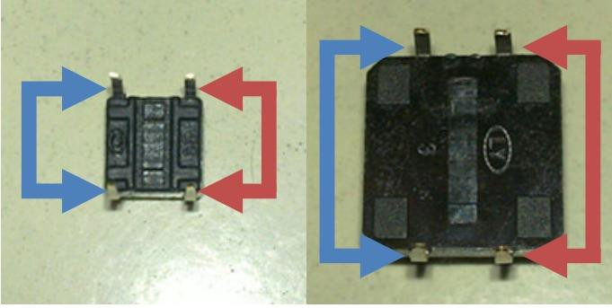

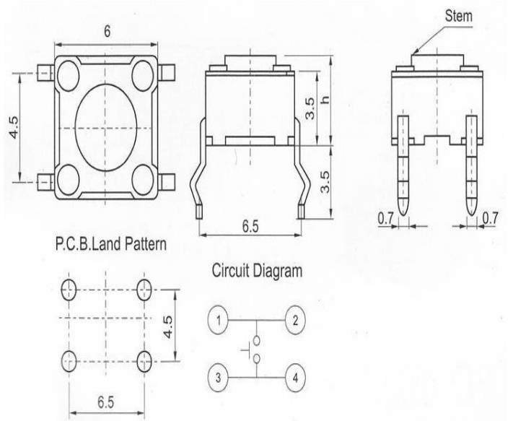

When the button is pressed, the pins pointed by the blue arrows will connect to the pins pointed by the red arrows.

Generally, the button switch is directly connected in an LED circuit in order to turn the LED on or off. This connection is relatively simple. However, sometimes the LED will light up automatically without pressing the button, which is caused by various interferences. In order to avoid these external interferences, we will connect a pull-down resistor, that is, connect a 1K–10KΩ resistor between the button port and the GND. The function of the pull-down resistor is to consume external interferences while connected to the GND for as long as the button switch is turned off.

This circuit connection is widely used in numerous circuits and electronic devices. For example, if you press any button on your mobile phone, the backlight will light up.

## Experimental Procedures

**Step 1:** Connect circuit as shown in the following diagram:

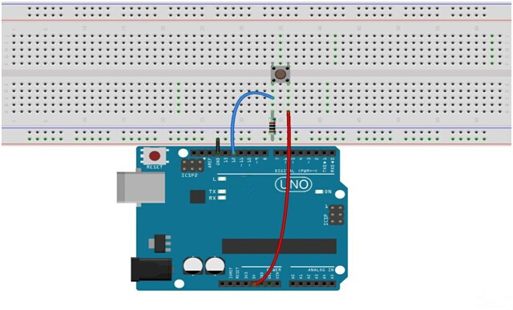

The corresponding schematic diagram is as follows:

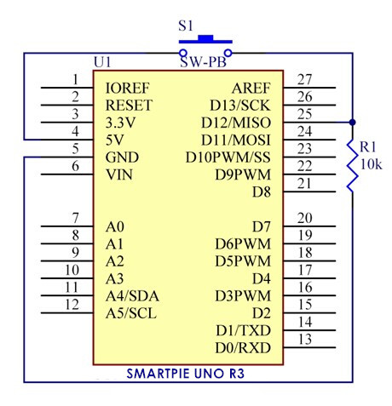

**Step 2:** Program (please refer to the example code on the CD or official website)

**Step 3:** Compile the program

**Step 4:** Burn the program into RobotLinking Uno board

If you press the button, the LED on the RobotLinking Uno board will light up.

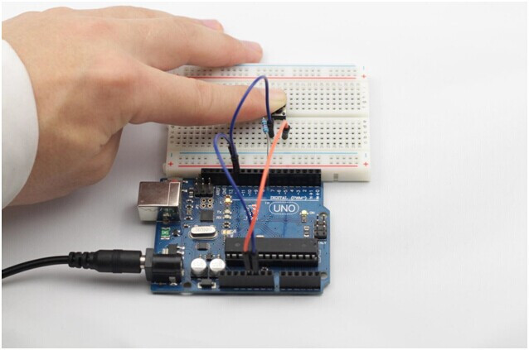

## Experimental Summary

Buttons are a very simple, very practical technology that is surprisingly easy to master. If you feel as though you're struggling, check out our video tutorials on [www.RobotLinking.com](http://www.sunfounder.com/) or ask us questions on our forum.

# Lesson 2 Flowing LED Lights

## Introduction

In this lesson, we’ll conduct a simple yet interesting experiment – using LEDs to create flowing LED lights. As the name implies, these flowing lights are made up of eight LEDs in a row which successively light up and dim one after another like flowing water.

## Components

* 1 * RobotLinking Uno board
* 1 * Breadboard
* Jumper wires
* 8 * LED
* 8 * Resistor (220Ω)
* 1 * USB cable

## Principle

The principle of this experiment is simply to turn eight LEDs on in turn.

## Experimental Procedures

**Step 1**: Connect circuit as shown in the following diagram

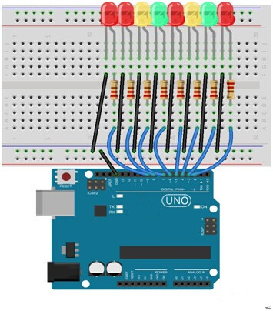

The corresponding schematic diagram is as follows:

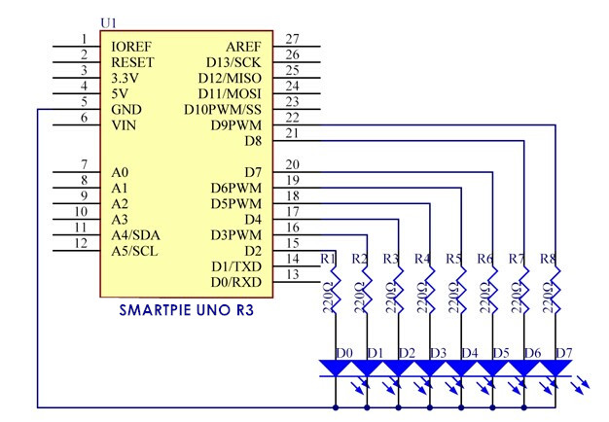

**Step 2:** Program (please refer to the example code on the CD or official website)

**Step 3:** Compile the program

**Step 4:** Burn the program into RobotLinking Uno board

Here you should see eight LEDs light up one by one from left to right, and then go out one by one from right to left. After that, the LEDs will light up one by one from right to left, and then go out one by one from left to right. This process will repeat indefinitely.

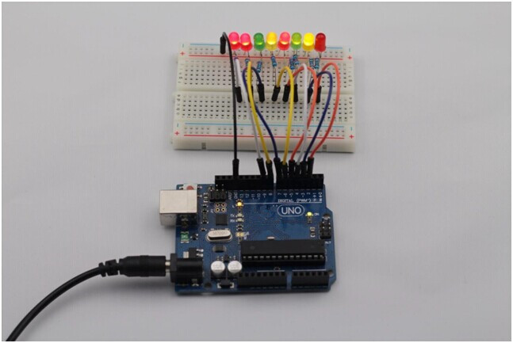

## Experimental Summary

This simple experiment helps to increase proficiency in applying LEDs. Furthermore, you can modify the provided program to create all kinds of fantastic patterns!

### Introduction

# Lesson 3 Buzzer

You can use a buzzer whenever you want to make some noise.

### Experimental Conditions

* 1 * RobotLinking Uno board
* 1 * Breadboard
* 1 * USB data cable
* 1 * Buzzer (Active)
* Jumper wires

### Principle

As a type of electronic buzzer with integrated structure, buzzers, which are supplied by DC power, are widely used in computers, printers, photocopiers, alarms, electronic toys, automotive electronic devices, telephones, timers and other electronic products for voice devices. Buzzers can be categorized as active and passive ones (see the following picture). Turn the pins of two buzzers face up, and the one with a green circuit board is a passive buzzer, while the other enclosed with a black tape is an active one.

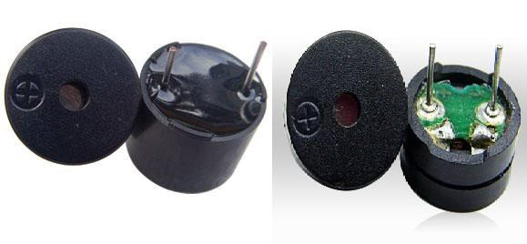

The difference between an active buzzer and a passive buzzer is:

An active buzzer has a built-in oscillating source, so it will make sounds when electrified. But a passive buzzer does not have such source, so it will not tweet if DC signals are used; instead, you need to use square waves whose frequency is between 2K and 5K to drive it. The active buzzer is often more expensive than the passive one because of multiple built-in oscillating circuits.

In this experiment, we use the active buzzer.

### Experimental Procedures

**Step 1:** Connect circuit as shown in the following diagram:

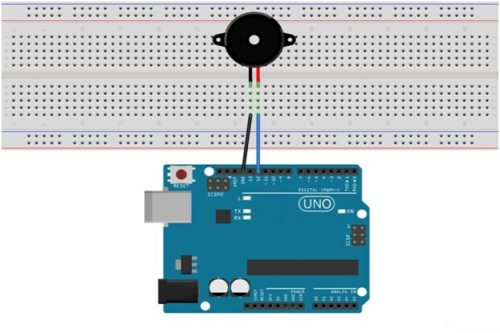

The corresponding schematic diagram is as follows:

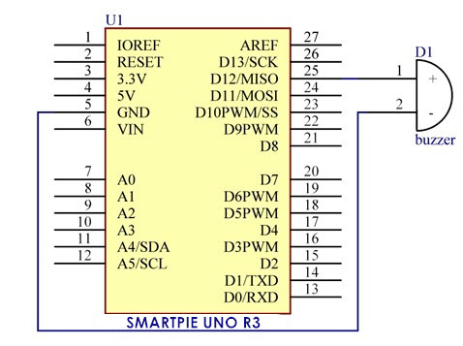

**Step 2:** Program (please refer to the example code on the CD or official website)

**Step 3:** Compile the program

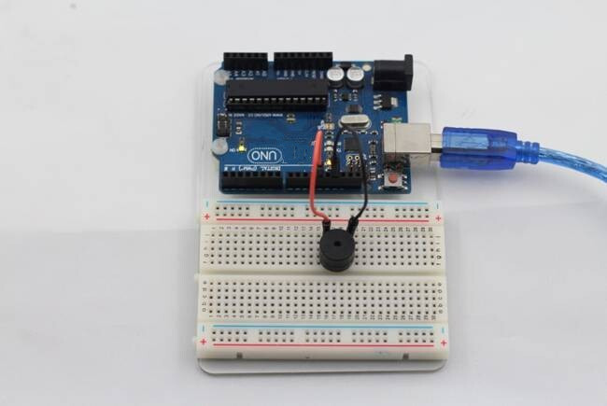**Step 4:** Burn the program into RobotLinking Uno board Now, you should hear the buzzer make sounds.

# Lesson 4 Photoresistor

## Introduction

A photoresistor or photocell is a light-controlled variable [resistor](http://en.wikipedia.org/wiki/Resistor). The [resistance](http://en.wikipedia.org/wiki/Electrical_resistance) of a photoresistor decreases with increasing incident light intensity; in other words, it exhibits [photoconductivity](http://en.wikipedia.org/wiki/Photoconductivity). A photoresistor can be applied in light-sensitive detector circuits, and light- and dark-activated switching circuits.

## Experimental Conditions

* 1 * RobotLinking Uno board
* 1 * USB data cable
* 1 * Photoresistor
* 1 * Resistor (10KΩ)
* 8 * LED
* 8 * Resistor (220Ω)
* Jumper wires

-1 * Breadboard

## Experimental Principle

The resistance of the photoresistor changes with incident light intensity. If the incident light intensity is high, the resistance reduces; if low, increases.

In this experiment, we will use eight LEDs to indicate light intensity. The higher the light intensity is, the more the LED is lit. When the light intensity is high enough, all the LEDs will be lit. When there is no light, all the LEDs will go out.

## Experimental Procedures

**Step 1:** Connect circuit as shown in the following diagram:

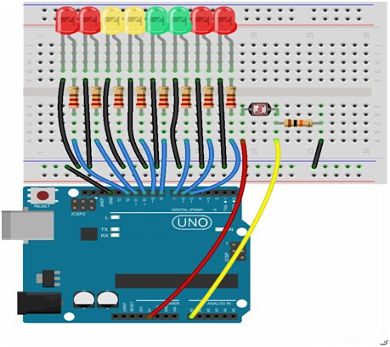

The corresponding schematic diagram is as follows:

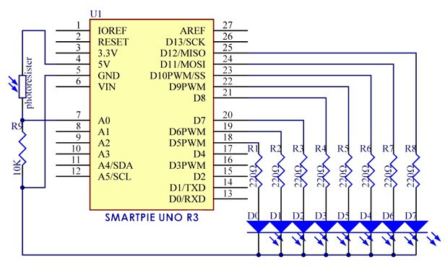

**Step 2:** Program (please refer to the example code on the CD or official website)

**Step 3:** Compile the program

**Step 4:** Burn the program into RobotLinking Uno board

Now, if you shine the photoresistor with a certain light intensity, you will see several LEDs light up. If you increase the light intensity, you will see more LEDs light up. When you place it in dark environment, all the LEDs will go out.

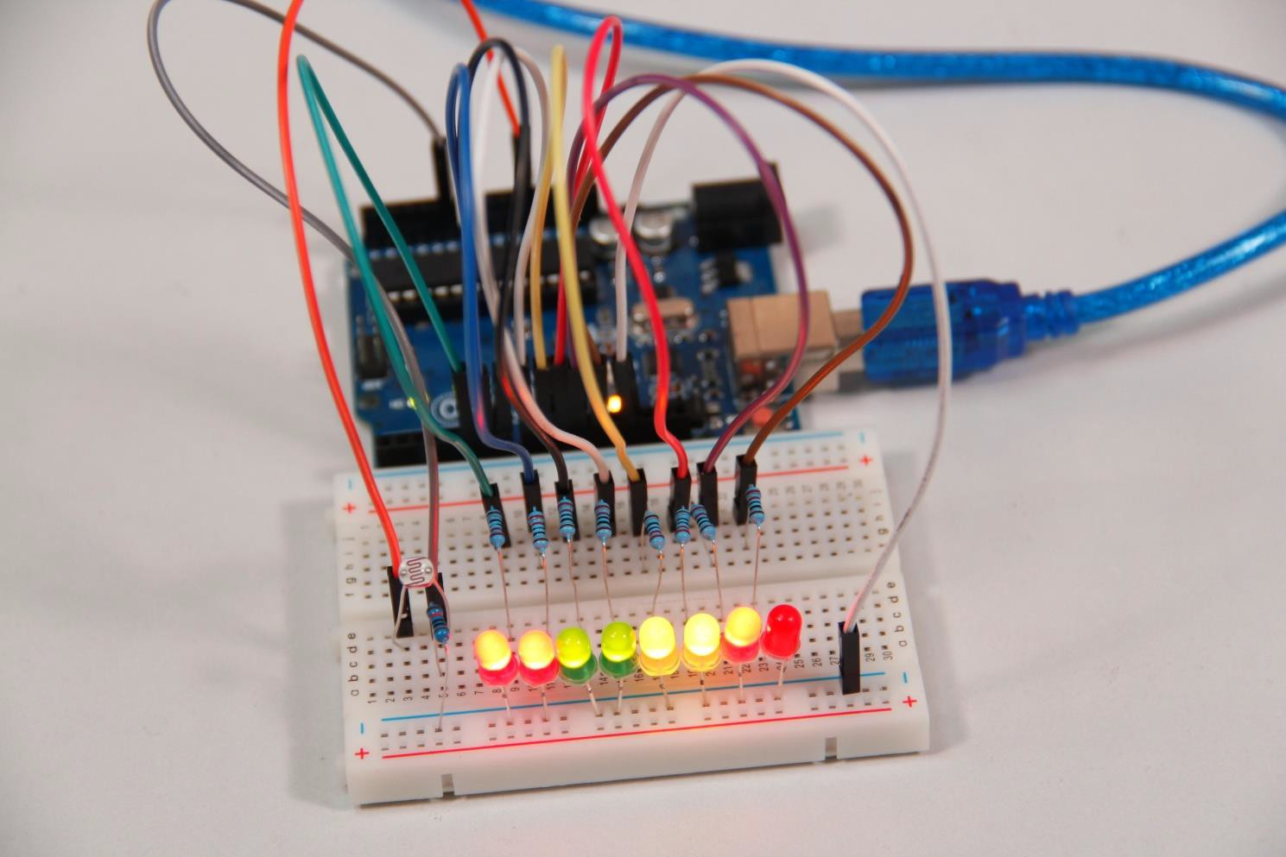

## Exploration

In addition, you can replace the photoresistor with a microphone to use LEDs to indicate sound intensity. The higher the sound intensity is, the more LEDs are lit. You can realize this effect by yourself.

# Lesson 5 RGB LED

## Introduction

For this lesson, we will use PWM to control a RGB LED and cause it to display multiple colors.

## Components

* 1 * RGB LED
* 3 * Resistor (220Ω)
* 1 * Breadboard
* 1 * RobotLinking Uno board
* Jumper wires
* USB cable

## Principle

### Color Principle of RGB

RGB stands for the red, green, and blue color channels and is an industry color standard. RGB displays various new colors by changing the three channels and superimposing them, which, according to statistics, can create 16,777,216 different colors. If you say the color displayed doesn't completely match a natural color, then it almost certainly cannot be differentiated with the naked eye.

Each of the three color channels of red, green, and blue has 255 stages of brightness. When the three primary colors are all 0, "LED light" is the darkest, that is, it turns off. When the three primary colors are all 255, "LED light" is the brightest. When superimposing the light emitted by the three primary colors, the colors will be mixed. However, the brightness is equal to the sum of all brightness, and the more you mix, the brighter the LED is. This process is known as additive mixing.

In this experiment, we will also use PWM which you have learnt in super kit. Here we input any value between 0 and 255 to the three pins of the RGB LED to make it display different colors.

## Experimental Procedures

**Step 1:** Connect circuit as shown in the following diagram:

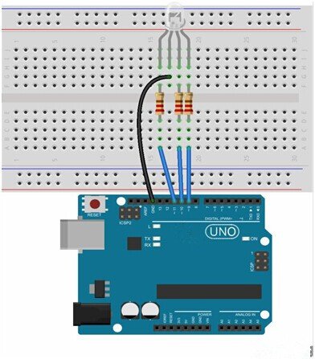

The corresponding schematic diagram is as follows:

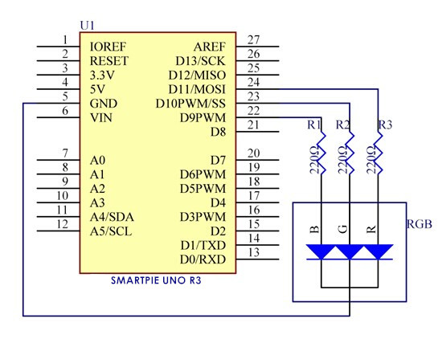

**Step 2:** Program (please refer to the example code on the CD or official website)

**Step 3:** Compile the program

**Step 4:** Burn the program into RobotLinking Uno board

The RGB LED will appear red, green, and blue first, then red, orange, yellow, green, blue, indigo, and purple.

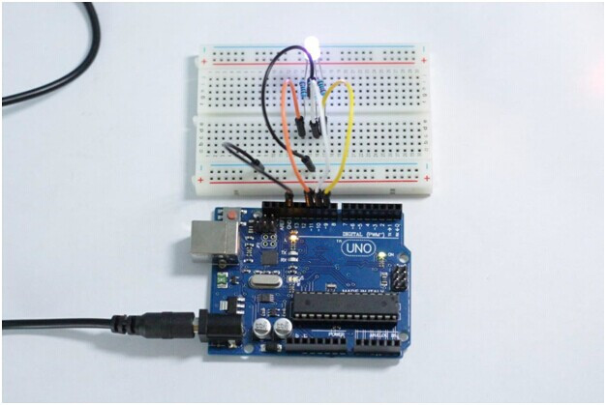

# Lesson 6 Relay

## Introduction

Relays are suitable for driving high power electric equipment, such as lights, electric fans and air conditioning. We can use a relay to realize low voltage to control high voltage by connecting it to MCU.

## Components

**-** 1 * RobotLinking Uno board

* 1 * USB data cable
* 1 * Relay
* 1 * LED
* 1 * Resistor (220Ω)
* 1 * Resistor (1KΩ)
* 1 * NPN Transistor
* 1 * Diode (Rectifier)
* Several jumper wires
* 1 * Breadboard

## Experimental Principle

A relay is an electronic control component with control system and controlled system. It is generally used in automatic control circuit. Actually, it is an "automatic switch" which uses low current to control high current. It plays a role of automatic regulation, security protection and circuit switch.

An electromagnetic relay is generally composed of iron core, coil and armature, contact reeds, etc. There will be electric current flowing through the coil as long as a certain voltage is supplied on both ends of the coil so as to generate electromagnetic effect. The armature will overcome spring tension to suck the iron core to drive the armature's movable contact and static contact (normally open contact) suction under electromagnetic attraction. After the coil is power off, electromagnetic suction will also disappear. The armature will return to the original position under the spring reactive force, leading to the movable contact suction with the original static contact (normally closed contact). This suction and release achieve the purpose of circuit conduction and cut off. For relay "normally open and normally closed" contacts, it can be distinguished like this: when relay coil is not energized, static contact in disconnected state is called "normally open contact"; static contact in connected state is called "normally closed contact".

In this experiment, when the relay sucks, the LED will light up; when the relay breaks, the LED will go out.

## Experimental Procedures

**Step 1:** Connect circuit as shown in the following diagram:

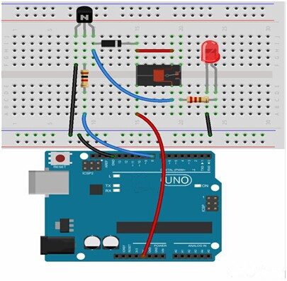

The corresponding schematic diagram is as follows:

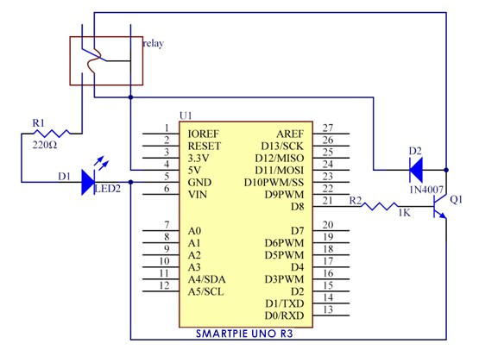

**Step 2:** Program (please refer to the example code on the CD or official website)

**Step 3:** Compile the program

**Step 4:** Burn the program into ROBOTLINKING UNO board

Now, if a high voltage is supplied, the relay will suck and the LED will light up; if a low voltage is supplied, the relay will break and the LED will go out. In addition, you can hear ticktock caused by breaking normally closed contact and closing normally open contact.

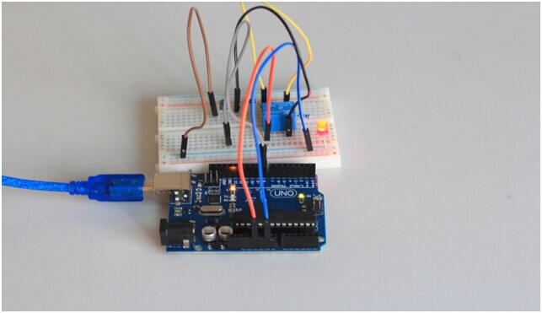

# Lesson 7 Tilt-Switch

## Introduction

The tilt-switch we use is a ball one with a metal ball inside. It is used to detect small angle of inclination.

## Components

**-** 1 * RobotLinking Uno board

* 1 * USB data cable
* 1 * Tilt-switch
* Several jumper wires

## Experimental Principle

The principle is very simple. It mainly uses the ball in the switch changing with different angle of inclination to achieve the purpose of triggering circuits. When the ball in tilt switch runs from one end to the other end because of external force shaking, the tilt switch will conduct, or it will break.

## Experimental Procedures

**Step 1:** Connect circuit as shown in the following diagram:

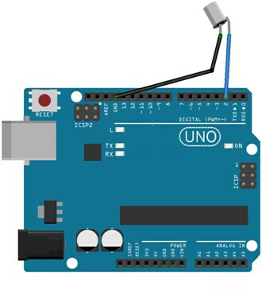

The corresponding schematic diagram is as follows:

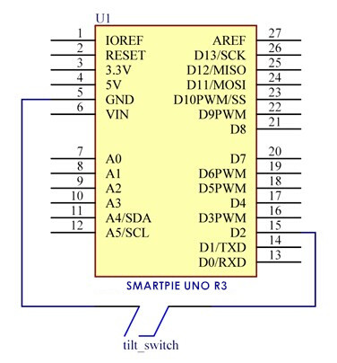

**Step 2:** Program (please refer to the example code on the CD or official website)

**Step 3:** Compile the program

**Step 4:** Burn the program into RobotLinking Uno board

Now, if you tilt the switch, the LED attached to pin 13 on RobotLinking Uno board will light up.

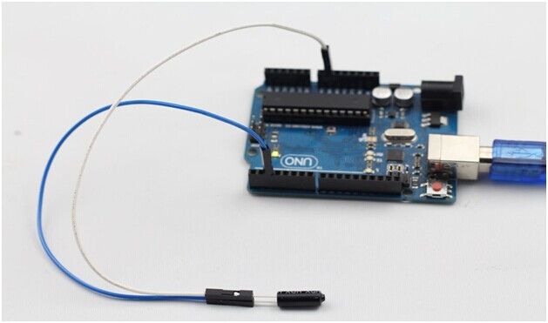

# Lesson 8 Servo

## Introduction

Servo is a type of geared motor that can only rotate 180 degrees. It is controlled by sending electrical pulses from your RobotLinking Uno board. These pulses tell the servo what position it should move to. A servo has three wires, the brown wire is GND, the red one is VCC, and the orange one is signal line.

## Components

**-** 1 * RobotLinking Uno board

* 1 * USB data cable
* 1 * Servo
* Several jumper wires

## Experimental Principle

Servo consists of shell, circuit board, non-core motor, gear and location detection. Its working principle is as follows: RobotLinking Uno board sends PWM signal to servo motor, and then this signal is processed by IC on circuit board to calculate rotation direction to drive the motor, and then this driving power is transferred to swing arm by reduction gear. At the same time, position detector returns location signal to judge whether set location is reached or not.

## Experimental Procedures

**Step 1:** Connect circuit as shown in the following diagram:

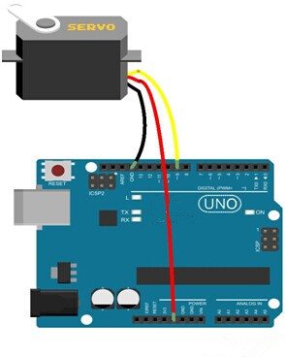

The corresponding schematic diagram is as follows:

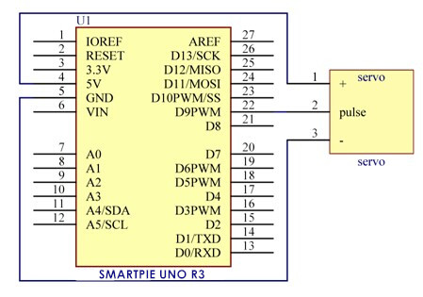

**Step 2:** Program (please refer to the example code on the CD or official website)

**Step 3:** Compile the program

**Step 4:** Burn the program into RobotLinking Uno board

Now, you can see the servo motor rotate 90 degrees (rotate once every 15 degrees). And then rotate in opposite direction.

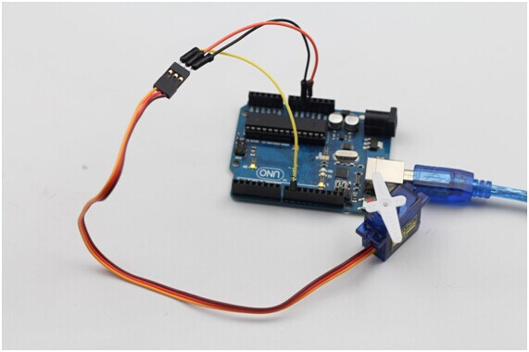

# Lesson 9 LCD1602

## Introduction

In this experiment, we will use the RobotLinking Uno board to directly drive LCD1602 to display characters.

## Components

* 1 * RobotLinking Uno board
* 1 * Breadboard

- 1 * LCD1602

* 1 * Potentiometer (50kΩ)
* Jumper wires
* 1 * USB cable

## Principle

Generally speaking, LCD1602 has parallel ports, that is, it needs to control several pins at the same time. LCD1602 can be categorized into an eight-port connection and four-port connection. If the eight-port connection is used, then the digital ports of the RobotLinking Uno board are basically completely occupied. If you want to connect more sensors, there will be no ports available. Therefore, we will use the four-port connection.

Introduction to the pins of LCD1602:

**VSS:** A pin that connects to ground

**VDD:** A pin that connects to a +5V power supply

**VO:** A pin that adjust the contrast of LCD1602

**RS:** A register select pin that controls where in the LCD’s memory you are writing data to. You can select either the data register, which holds what goes on the screen, or an instruction register, which is where the LCD’s controller looks for instructions on what to do next.

**R/W:** A Read/Write pin that selects reading mode or writing mode

**E:** An enabling pin that, when supplied with low-level energy, causes the LDC module to execute relevant instructions.

**D0-D7：**Pins that read and write data

**A and K:** Pins that control the LED backlight

In this experiment, we will use a 50KΩ potentiometer to adjust the contrast of LCD1602 to display characters or figures however you want. For programming, we will optimize it by calling function libraries.

## Experimental Procedures

**Step 1:** Connect circuit as shown in the following diagram (please make sure pins are connected correctly or characters will not display properly):

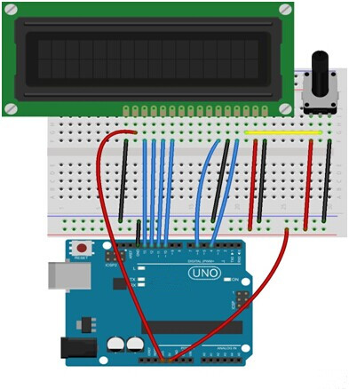

The corresponding schematic diagram is as follows:

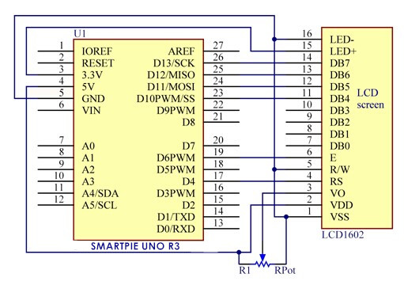

**Step 2:** Program (please refer to the example code on the CD or official website)

**Step 3:** Compile the program

**Step 4:** Burn the program into RobotLinking Uno board

You should now see your LCD1602 display the flowing characters "ROBOTLINKING" and "hello, world! ".

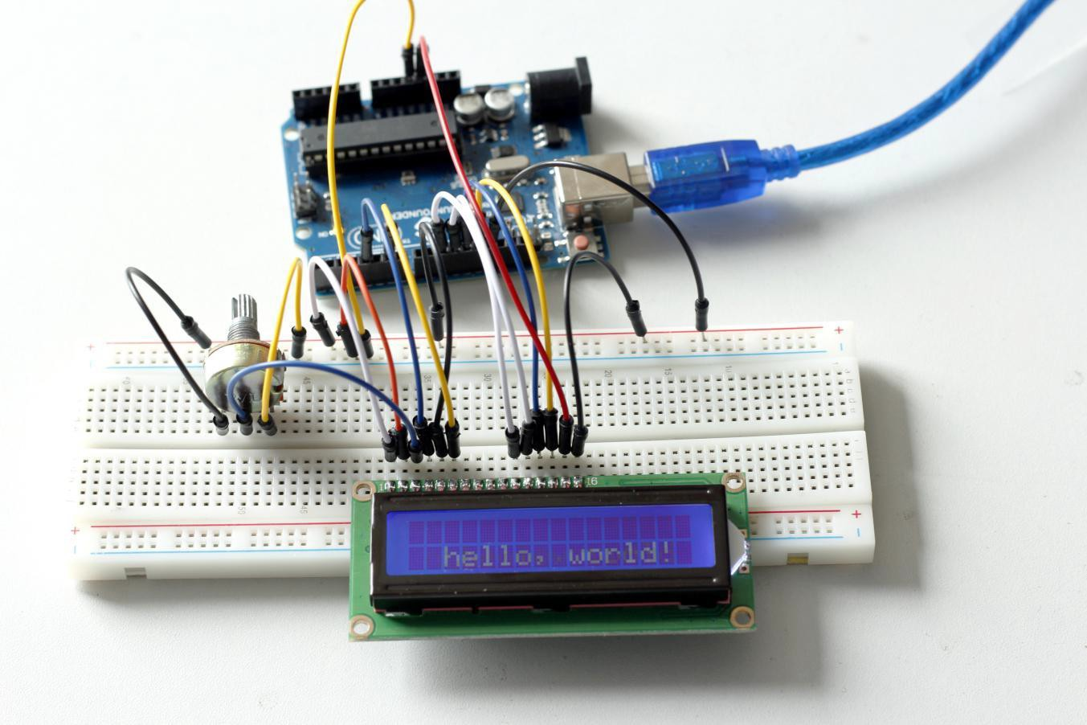

## Experimental Summary

Through this experiment, you've learned how to drive LCD1602. Now you can create your own messages to display! You can also try letting your LCD1602 display numbers.

# Lesson 10 Thermistor

## Introduction

A thermistor is a type o[f resistor](http://en.wikipedia.org/wiki/Resistor) whose [resistance](http://en.wikipedia.org/wiki/Electrical_resistance) varies significantly with [temperature](http://en.wikipedia.org/wiki/Temperature).

## Components

**-** 1 * RobotLinking Uno board

* 1 * USB data cable

-1 * Breadboard

* 1 * Thermistor
* Several jumper wires

-1 * Potentiometer (50KΩ)

-1 * Resister (10KΩ)

-1 * LCD1602

## Experimental Principle

The [resistance](http://en.wikipedia.org/wiki/Electrical_resistance) of the thermistor varies significantly with ambient [temperature](http://en.wikipedia.org/wiki/Temperature). It can detect surrounding temperature changes in real time. Send the temperature data to analog I/O port of RobotLinking Uno board. Next we only need to convert sensor output to Celsius temperature by simple programming and display it on the LCD1602.

## Experimental Procedures

**Step 1:** Connect circuit as shown in the following diagram:

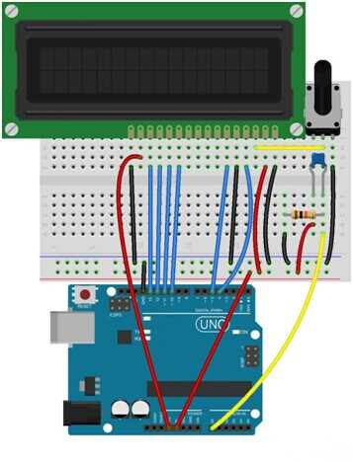

The corresponding schematic diagram is as follows:

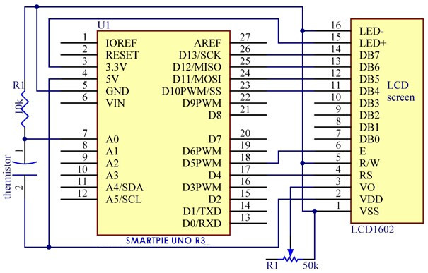

**Step 2:** Program (please refer to the example code on the CD or official website)

**Step 3:** Compile the program

**Step 4:** Burn the program into RobotLinking Uno board

Now, you can see current temperature displayed on LCD1602 both in Celcius and Fahrenheit degrees.

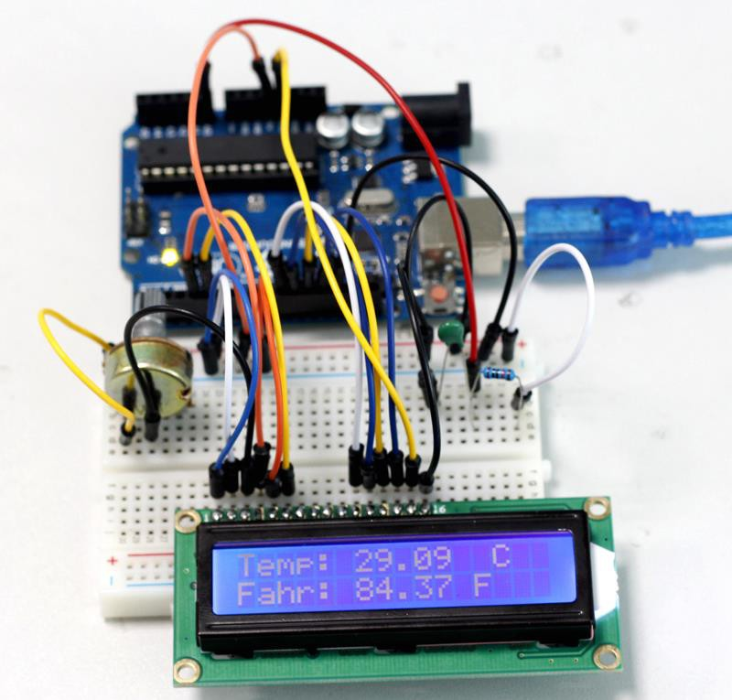

# Lesson 11 Voltmeter

## Introduction

In this lesson, we will use two potentiometers and a LCD1602 to make a voltmeter.

## Components

**-** 1 * RobotLinking Uno board

* 1 * USB data cable
* 2 * Potentiometer

- 1 * LCD1602

* Several jumper wires

-1 * Breadboard

## Experimental Principle

One potentiometer is used to adjust the contrast of the LCD1602. And the other is used to divide voltage.

## Experimental Procedures

**Step 1:** Connect circuit as shown in the following diagram:

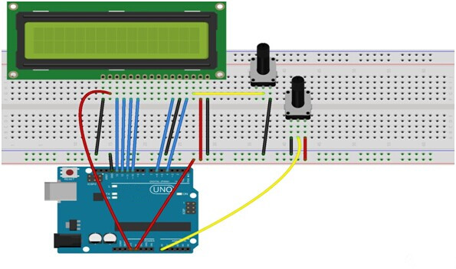

The corresponding schematic diagram is as follows:

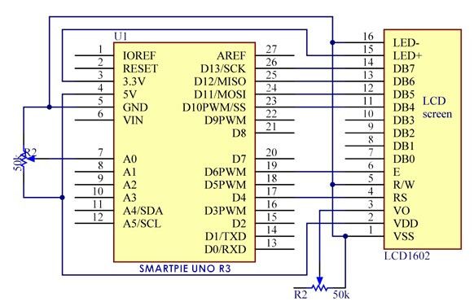

**Step 2:** Program (please refer to the example code on the CD or official website)

**Step 3:** Compile the program

**Step 4:** Burn the program into RobotLinking Uno board

Now, if you adjust the potentiometer which is used to divide voltage, you will see the voltage value displayed on the LCD1602 varies.

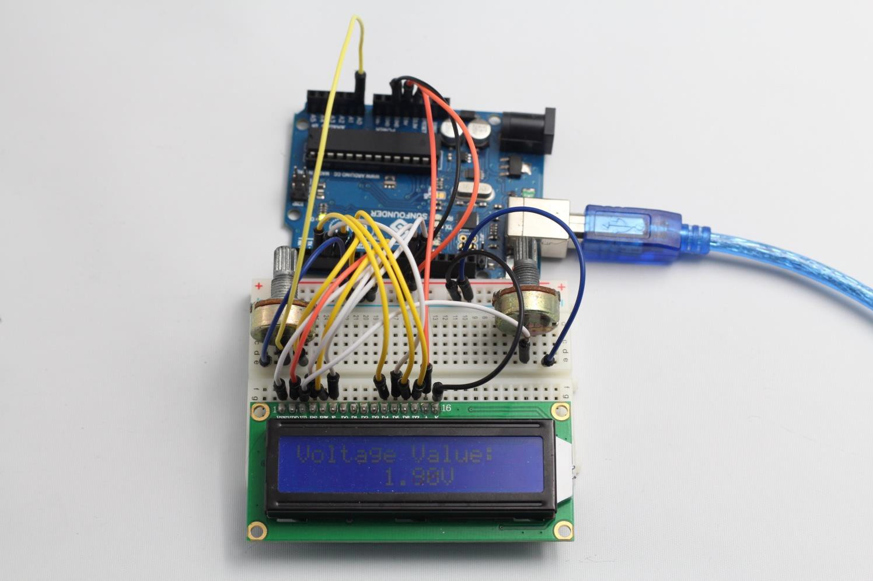

# Lesson 12 Automatically Tracking Light Source

## Introduction

In this lesson, we will use a servo motor, a photoresistor and a pull-down resistor to assemble an automatically tracking light source system.

## Components

**-** 1 * RobotLinking Uno board

* 1 * Servo motor
* 1 * Photoresistor
* 1 * Resistor (10KΩ)
* Several jumper wires

-1 * USB data cable

## Experimental Principle

The servo motor and the photoresistor scan and look for light source in 180 degree and record the location of light source. After finishing scanning, the servo motor and the photoresistor stop at the direction of light source.

## Experimental Procedures

**Step 1:** Connect circuit as shown in the following diagram:

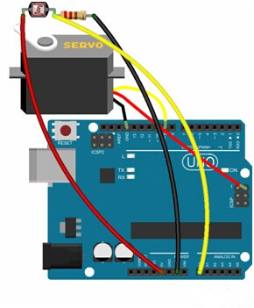

Note: you need to bind one end of the resistor and photoresistor to the wing of the servo, as shown below:

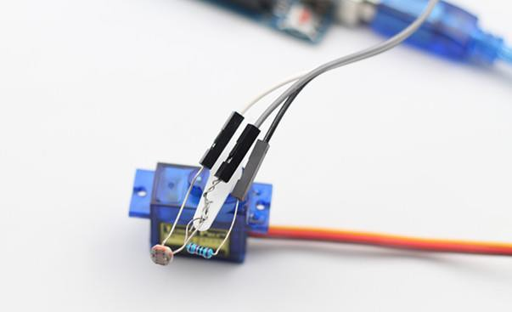

The corresponding schematic diagram is as follows:

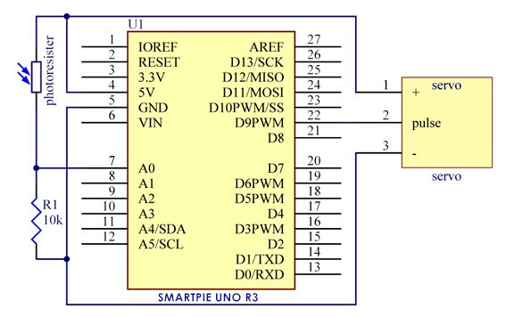

**Step 2:** Program (please refer to the example code on the CD or official website)

**Step 3:** Compile the program

**Step 4:** Burn the program into RobotLinking Uno board

Now, if you use a flashlight to shine the photoresistor, you will see the servo motor and the photoresistor rotate, finally stop at the direction of light source.

